Software Detail Design
for
Desktop Project
Blue Crab Health Calculator
Version 1.1
Prepared by Lincoln Powell
SWEN 661 9040 (2182)
User Interface Implementation
Dr. James Dollens
February 25, 2018
Table of Contents

1. Introduction 1
1.1 Purpose 1
1.2 Scope 1
1.3 Overview 1
1.4 Reference Material 2
1.5 Definitions and Acronyms 2
2. System Overview 2
3. System Architecture 3
3.1 Architectural Design 3
3.2 Decomposition Description 4
3.3 Exception Handling 4
3.4 Design Rationale 4
4. Data Design 4
4.1 Data Description 4
4.2 Data Dictionary 5
5. Component Design 6
6. Human Interface Design 7
6.1 Overview of User Interface 7
6.2 Screen Images 8
6.3 Screen Objects and Actions 9
7. Requirements Matrix 10
8. Appendices 10

Revision History

Name | Date | Reason for changes | Version
Lincoln Powell | 2/11/18 | Initial document | 1.0
Lincoln Powell | 2/25/18 | Stakeholder feedback | 1.1

Introduction

Purpose
The purpose of this Software Detail Design document is to describe the architecture and system design of the Blue Crab Health Calculator application being developed for the User Interface Implementation course at University of Maryland University College (UMUC). This document is created to ensure that the Blue Crab Health Calculator design meets the requirements specified in the UMUC SWEN661 Desktop Project documentation as well as feedback from the primary stakeholder. This document is tailored for interested stakeholders; however, information within is primarily targeted towards the project development team.

Scope
The scope of the Blue Crab Health Calculator application includes its distinct features, benefits and limitations. The application’s distinct features allow a user to determine if a sampled blue crab is healthy or not healthy using four conditions or rules for healthiness: (1) the color scale score is greater than seven; (2) the weight is greater than ten ounces and the date if after July 15th; (3) the length is greater than five inches; (4) the color scale score is greater than five, the weight is greater than eight ounces and the length is greater than five inches. If a sampled blue crab does not meet the preceding criteria, the application should state that the blue crab is unhealthy. The application grants the benefit to quickly determine blue crabs’ healthiness using a mobile application. The application will be limited to determining the healthiness of one blue crab at a time with no batch data analysis. Data outputted from the application will not be saved.

Overview
This document is organized as follows:

- Section 1: An introduction to the documentation by explaining the purpose of the document, providing terms and references and a brief overview of each section within the document.
- Section 2: A general description of the functionality, context and design of the application along with background information, as necessary.
- Section 3: An overview of the system architecture, system components, relationships between the various components and design rationale.
- Section 4: An explanation of how the information domain of the system is transformed into data structures and how major data/entities are stored, processed and organized along with providing a listing of system entities/major data, functions, function parameters, objects, attributes, methods and method parameters.
- Section 5: A detailed description of each component, summarizing each object member function along with providing a listing of each class, its name, description, modifiers, inheritance, attributes, exceptions thrown, and methods.
- Section 6: An overview of the user interface describing the functionality of the system from the user’s perspective along with providing screen images.
- Section 7: A table mapping system requirements to specific classes and methods.
- Section 8: An appendix.

Reference Material
UMUC SWEN661 Desktop Project [docx]. (n.d.). Document posted in University of Maryland University College SWEN 661 9040 online classroom, archived at: http://campus.umuc.edu

Definitions and Acronyms
Color scale score A numeric score, in the range of 1 to 10, indicating the shade of blue of a blue crab.

System Overview
According to the UMUC SWEN661 Desktop Project documentation (n.d.), the Blue Crab Health Calculator application is broken into three stages: input, process and output. In the input stage, data should be collected from the user using presented selection criteria, such as a dropdown box, limiting applicable choices and allowing the user to select one item. There are five input attributes which the application should allow a user to enter: (1) month, displayed in the range of 1 to 12; (2) day of month, displayed in the range of 1 to 31; (3) color scale score, displayed in the range of 1 to 10; (4) weight, entered as a String value; (5) length, entered as a String value. During the process stage, the application will undergo a series of conditional structures to determine the results of the four rules (see Section 1.2, p. 1). Finally, in the output stage, the application will notify the user that the blue crab, given its inputted attributes, is healthy or unhealthy.

System Architecture

Architectural Design
The following is the class diagram of the Blue Crab Health Calculator software architecture:

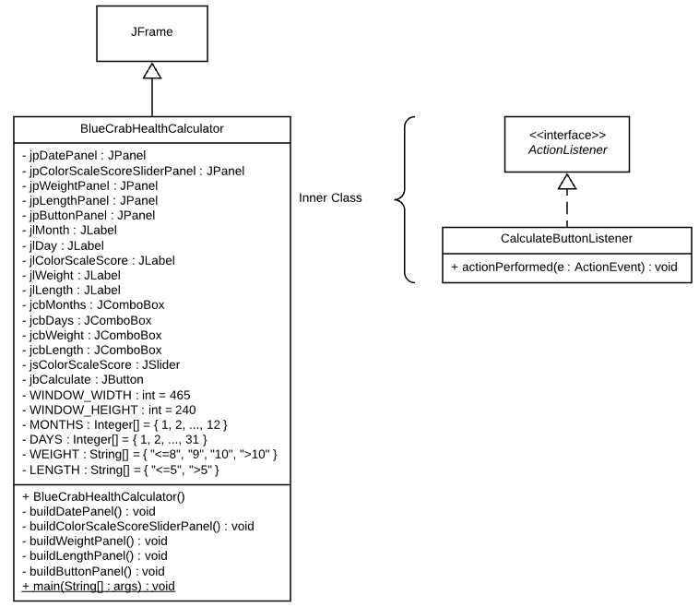
Figure 1. Blue Crab Health Calculator UML diagram.

Decomposition Description
The system is focused on a single class, BlueCrabHealthCalculator, housing an inner class, CalculateButtonListener, which fires a when button is pressed action that initiates the conditional logic and displays “The blue crab is healthy” or “The blue crab is unhealthy” based off the results of the conditional logic.

Upon instantiating a BlueCrabHealthCalculator object, a frame will be created, adding panels, which, in turn, add required components in order to construct a clear graphical user interface.

Exception Handling
The system will handle exceptions through limiting data options within lists in combo boxes and sliders. Thus, the system will not necessitate explicit error handling.

Design Rationale
The system design has been selected as an optimal choice due to satisfying all stakeholder requirements and offering a minimalistic approach to solve the problem. The design is modular allowing new components and features to be included.

Various layout managers and components were heavily scrutinized for their familiarity with inputted attributes, look, feel and responsiveness.

The resultant graphical user interface chosen is representative of limited input warranted by stakeholder requirements. Thus, combo boxes were chosen for the month, day, weight and length data entry; a slider was chosen for selecting the color scale score.

A calculate button was added as a firing event to initiate the conditional logic, using data presented in each attribute component in the application’s graphical user interface.

Options to include a clear or reset button was considered; however, was not implemented due to gold plating concerns. Such features can be marked as future TODOs, as project needs direct, or weighed during the project retrospective.

Data Design

Data Description
All data stored within each component is stored at runtime for calculating a blue crab’s healthiness and will not be saved upon program termination. More, all inputted data will be stored as integers.

Data Dictionary
Object Name: BlueCrabHealthCalculator
Object Attributes:
- private JPanel jpDatePanel
- private JPanel jpColorScaleScoreSliderPanel
- private JPanel jpWeightPanel
- private JPanel jpLengthPanel
- private JPanel jpButtonPanel
- private JLabel jlMonth
- private JLabel jlDay
- private JLabel jlColorScaleScore
- private JLabel jlWeight
- private JLabel jlLength
- private JComboBox jcbMonths
- private JComboBox jcbDays
- private JComboBox jcbWeight
- private JComboBox jcbLength
- private JSlider jsColorScaleScore
- private JButton jbCalculate
- private final int WINDOW_WIDTH
- private final int WINDOW_HEIGHT
- private final Integer[] MONTHS
- private final Integer[] DAYS
- private final String[] WEIGHT
- private final String[] LENGTH
Object Methods:
- public BlueCrabHealthCalculator()
- private void buildDatePanel()
- private void buildColorScaleScoreSliderPanel()
- private void buildWeightPanel()
- private void buildLengthPanel()
- private void buildButtonPanel()
- public static void main(String[] args)

Object Name: CalculateButtonListener
Object Attributes:
- None
Object Methods:
- public void actionPerformed(ActionEvent e)

Component Design
Class Name: BlueCrabHealthCalculator
Class Description/Purpose: Serves as the main class for the application; upon instantiation, displays a graphical user interface of the application to the user.
Class Modifiers: Public
Class Inheritance: Inherits JFrame
Class Attributes:
- private JPanel jpDatePanel – a panel for the date (month and day) label and combo box components
- private JPanel jpColorScaleScoreSliderPanel – a panel for the color scale score label and slider components
- private JPanel jpWeightPanel – a panel for the weight label and combo box components
- private JPanel jpLengthPanel – a panel for the length label and combo box components
- private JPanel jpButtonPanel – a panel for the calculate button component
- private JLabel jlMonth – a label displaying “Month:”
- private JLabel jlDay – a label displaying “Day:”
- private JLabel jlColorScaleScore – a label displaying “Color Scale Score:”
- private JLabel jlWeight – a label displaying “Weight:”
- private JLabel jlLength – a label displaying “Length:”
- private JComboBox jcbMonths – a combo box containing numeric months (1 – 12)
- private JComboBox jcbDays – a combo box containing numeric days (1 – 31)
- private JComboBox jcbWeight – a combo box containing weight choices of <=8, 9, 10 and >10 ounces
- private JComboBox jcbLength – a combo box containing length choices of <=5 and >5 inches
- private JSlider jsColorScaleScore – a slider for the color scale score in the range of 1 – 10
- private JButton jbCalculate – a button for initiating a calculate event
- private final int WINDOW_WIDTH – a constant value for the frame’s width
- private final int WINDOW_HEIGHT – a constant value for the frame’s height
- private final Integer[] MONTHS – a constant Integer array to contain numeric months
- private final Integer[] DAYS – a constant Integer array to contain numeric days
- private final String[] WEIGHT – a constant String array to contain weight choices
- private final String[] LENGTH – a constant String array to contain length choices
Exceptions Thrown: None
Class Methods:
- Constructors:
  - public BlueCrabHealthCalculator()
    - Creates a BlueCrabHealthCalculator object.
- private void buildDatePanel()
  - Adds the month and day labels and combo boxes to a panel.
- private void buildColorScaleScoreSliderPanel()
  - Adds the color scale score label and slider to a panel.
- private void buildWeightPanel()
  - Adds the weight label and combo box to a panel.
- private void buildLengthPanel()
  - Adds the length label and combo box to a panel.
- private void buildButtonPanel()
  - Adds the calculate button to a panel.
- public static void main(String[] args)
  - Creates an instance of the BlueCrabHealthCalculator class, which causes it to display its window.

Class Name: CalculateButtonListener
Class Description/Purpose: Implements the ActionListener interface, tailoring the actionPerformed(ActionEvent e) method to fire the conditional logic to determine blue crab’s healthiness based on a series of rules.
Class Modifiers: Public
Class Inheritance: Implements ActionListener
Class Attributes: None
Exceptions Thrown: None
Class Methods:
- public void actionPerformed(ActionEvent e)
  - Executes calculation of a blue crab’s healthiness, using defaulted or inputted values from displayed components (e.g. month, day, color scale score, weight and length), when the user clicks on the calculate button.

Human Interface Design

Overview of User Interface
The user interface will consist of a window containing various components in which the user can interact with. The Blue Crab Health Calculator window includes: (1) a combo box listing the numeric month value, (2) a combo box listing the numeric day value, (3) a slider representing the color scale score, (3) a combo box for inputting the weight value, (4) a combo box for inputting the length value, (5) a button to initiate the calculation event and (6) labels depicting the intent for each component in simplistic form. Upon the launch of the Blue Crab Health Calculator application, the month and day components will be defaulted to initial values for user convenience using the date of the operating system. The user can then adjust these values according.

Screen Images

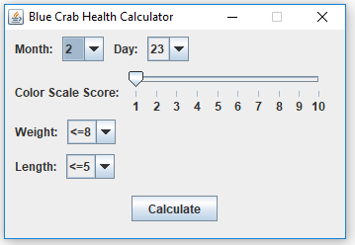
Figure 2. Screenshot of the Blue Crab Health Calculator displaying default values for components.

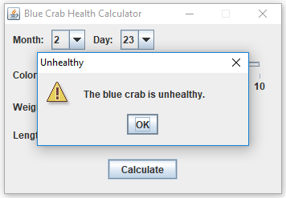
Figure 3. Screenshot showcasing unhealthy prompt.
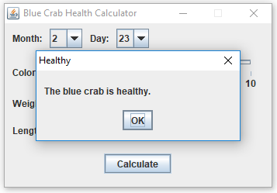
Figure 4. Screenshot showcasing healthy prompt.

Screen Objects and Actions
This section will discuss screen objects and their following associated actions:

- Calculation event fired from calculate button press
- Exiting the program

Calculation event fired from calculate button press

When a user first executes the Blue Crab Health Calculator application, each component representing an attribute to be evaluated for healthiness will be defaulted to initial values.

The user can initiate the calculate event via the Calculate button press at this time or adjust each component accordingly.

Next, in the process stage of the application, a series of conditional structures are evaluated to determine the results of the four rules for healthiness (see Section 1.2, p. 1).

Finally, in the output stage of the application, a prompt notifying the user whether the blue crab, given its inputted attributes, is healthy or unhealthy.

Exiting the program

To exit the program, click the ‘X’ at the upper-right corner the main window.

Requirements Matrix
Requirement | Class | Method
Design and build a blue crab health calculator application. | BlueCrabHealthCalculator | BlueCrabHealthCalculator()
The calculator should be able to allow a user to input month and day from a set of application values | BlueCrabHealthCalculator | buildDatePanel()
The calculator should be able to allow a user to choose a color scale score in the range of 1 to 10. | BlueCrabHealthCalculator | buildColorScaleScoreSliderPanel()
The calculator should be able to allow a user to input a weight value. | BlueCrabHealthCalculator | buildWeightPanel()
The calculator should be able to allow a user to input a length value. | BlueCrabHealthCalculator | buildLengthPanel()
The calculator should be able to allow a user to initiate the calculation event via button press. | CalculateButtonListener | actionPerformed(ActionEvent e)
The calculator should be able to validate user input against illogical or invalid values. | CalculateButtonListener | actionPerformed(ActionEvent e)
The calculator should be able to base healthiness on a series of conditional structures or rules. | CalculateButtonListener | actionPerformed(ActionEvent e)

Appendices
None.

